Patient Name | POORNIMA ACHARYA | Patient ID | 072429/17
Age/D.O.B | 060Y | Gender | F
Ref Doctor | DR ABINASH KUMAR SINGH, MS, MCH (NEURO) | Date | 30 Jul 24
MRI Brain Plain
History
trauma
Technique
T1W Sagittal, Dwi- b0, b500, b1000.
T2W Axial, Flair Coronal.
Observations
Concavoconvex area of T1 isointensity and T2 hyperintensity with blooming on GRE and restricted diffusion is noted in left fronto-temporal -parietal region and posterior part of falx cerebri with effacement of ipsilateral lateral ventricle and midline shift of 4.8 mm. S/o Acute Subdural haemorrhage.
Few other areas of blooming on GRE is are noted in right occipital lobe.
T2 FLAIR deep white matter hyperintensities in bilateral gangliocapsular area.
No evidence of abnormal signal intensity or volume loss in the hippocampii.
The thalami and internal capsules are normal on both sides.
The rest of ventricles and sulci are normal for the age.
The pituitary gland, infundibulum and hypothalamus are normal for the age.
The posterior fossa shows normal cerebellum.
The medulla, pons and mid brain shows normal signals in all the sequences.
Both CP angles are clear. The basal cisterns are normal.
Normal flow void is seen in the major dural venous sinuses and arteries
Impression
- Concavoconvex area of T1 isointensity and T2 hyperintensity with blooming on GRE and restricted diffusion is noted in left fronto-temporal-parietal region and posterior part of falx cerebri with effacement of ipsilateral lateral ventricle and midline shift of 4.8 mm. S/o Acute Subdural haemorrhage.
- Few other areas of blooming on GRE is are noted in right occipital lobe.
- T2 FLAIR deep white matter hyperintensities in bilateral gangliocapsular area. S/o small vessel ischaemic changes.
Advice
- Suggested CT brain R./O fracture for further evaluation, if clinically indicated.
Key Images
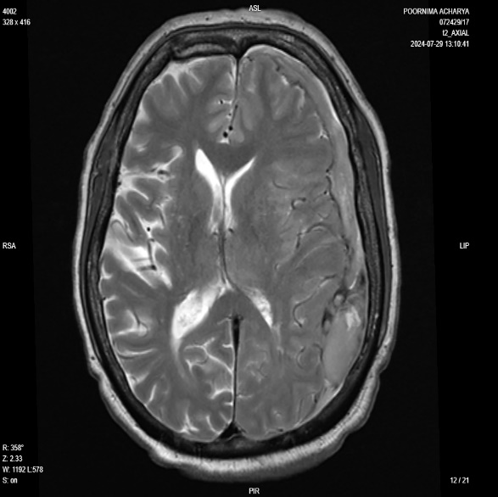
Image 1
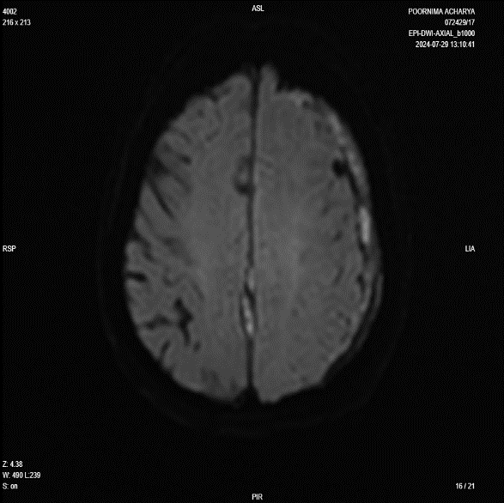
Image 2
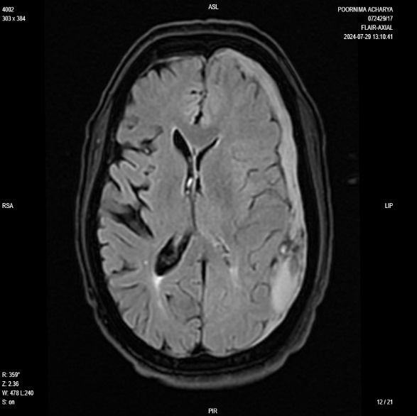
Image 3
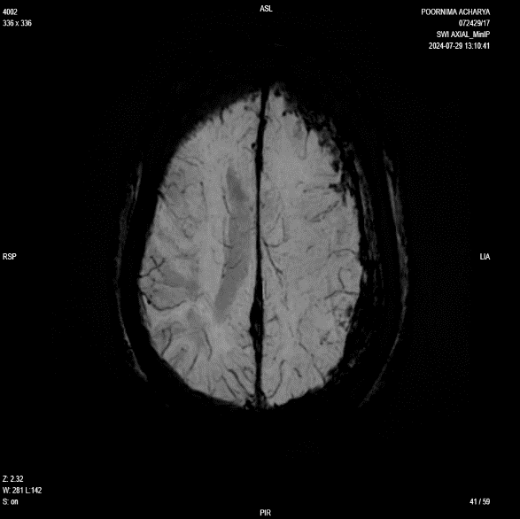
Image 4
Reported By,
Dr. Sultan Moinuddin
MBBS, MD
Consultant Radiologist
MMC - 2018/06/3061
Disclaimer
This medical diagnostic report is generated based on the image and patient information obtained from the source of origin, 5C Network assumes no responsibility for errors or omission of or in the image, or in the contents of the report, which are a direct interpretation of the image sent from source. In no event shall 5C Network be liable for any special, direct, indirect, consequential, or incidental damages or any damages whatsoever, whether in an action of negligence or other tort, arising out of or in connection with the use of the 5C Network Service or the contents of the Service. This report does not replace professional medical advice, additional diagnoses, or treatment.
Kindly call Help Desk (+91-95872 74858) for any report related query.
Powered by 5C Network. All Rights Reserved.

